RHYTHM & PURPOSE COLLECTIVE
Where Rhythm Meets Purpose
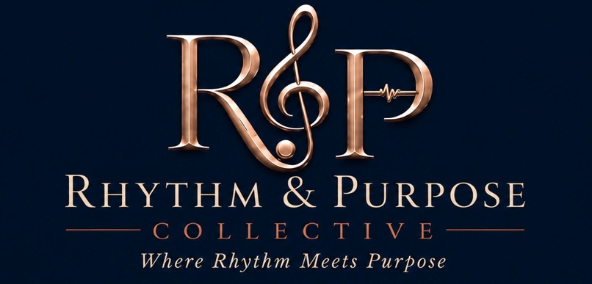
Vendor Program
Rhythm & Purpose: The R&B Experience | Sunday, October 18, 2026 | Fredericksburg Convention Center

1. Program Overview
The Rhythm & Purpose Vendor Marketplace gives a curated group of businesses direct access to 500 elevated-experience guests over a 6-hour event, cocktail hour, dinner, live performances, and dancing, in a dedicated marketplace setting just off the Ballroom. It's a chance to be seen by an audience that showed up ready to spend, connect, and discover local businesses, all while supporting a night that benefits a local nonprofit.
Vendors featured span fashion, beauty, lifestyle, wellness, authors, artisans, professional services, and community organizations — curated to fit the evening's elevated, “dress to impress” tone.

2. Maximum Vendor Count: 20
The marketplace is capped at 20 vendors, split across two dedicated vendor hallways (Behind Stage and Side), each with its own direct entrance from the Ballroom.
- Physical capacity: the venue offers two vendor hallways, each accessible via a dedicated entrance from the Ballroom on a different side. Real estate is fixed.
- Guest volume: 500 guests over a 6-hour program
- Traffic flow: with direct entrances from the Ballroom on two different sides, both hallways are naturally accessible to guests throughout the event.

3. Marketplace Tiers
Location | Tier | Price | Availability
Hallway 1- Right | Premium | $500 | 8 spots
Hallway 2- Left | Standard | $400 | 12 spots
TOTAL |  |  | 20 spots
A limited number of Entrance/Foyer tables are also available separately through our Bronze Sponsor tier ($1000, 2 spots) — those carry sponsor-level recognition in addition to a marketplace-style table, and are not counted against the 20-vendor cap above.
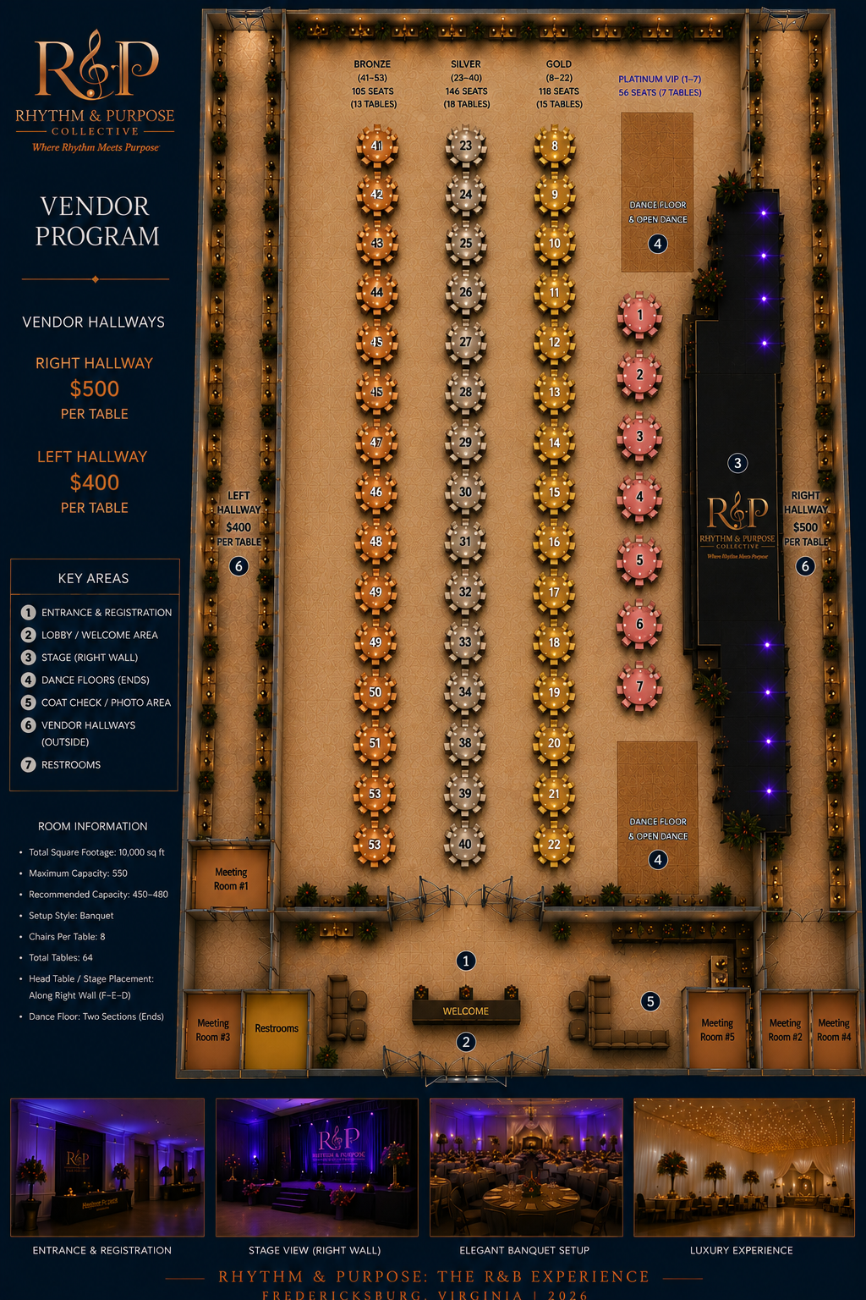

4. What's Included
- One 6' table and two chairs
- Standard electrical access (specify needs on application; limited availability, first-come basis)
- Listing in the event program and vendor marketplace signage
- Access to the full guest-facing program: cocktail hour, dinner, and the post-show open floor

5. Vendor Selection & Curation
Applications are reviewed to maintain category balance and fit with the evening's elevated tone. Priority is given to:
- Businesses that fit the fashion, beauty, lifestyle, wellness, authors, artisans, professional services, or community organization categories
- Category diversity — avoiding oversaturation of any single business type
- Local and regional businesses, consistent with the event's community-first mission
- Completed applications with payment, processed on a first-confirmed basis within each tier

6. Timeline
- Applications open: July 2, 2026
- Applications close / marketplace sells out: on a rolling basis, first-confirmed
- Vendor confirmations sent: within 5 business days of application + payment
- Load-in window: 12:00 PM – 3:00 PM day of event
- All vendor setups complete before Doors Open: 3:30 PM
- Event date: Sunday, October 18, 2026, 3:30 PM – 9:30 PM

7. Vendor Application
Complete the form below to apply for a Vendor Marketplace spot.

Vendor Information
Business Name
Contact Name
Phone
Email
Website / Social
Business Address

Category
Select the category that best describes your business:
- Fashion
- Beauty
- Lifestyle
- Wellness
- Authors
- Artisans
- Professional Services
- Community Organization
- Other: ______________________

Tier Requested
- Premium — Behind Stage Hallway ($500)
- Standard — Side Hallway ($400)
Electrical Needed?
Special Requests

Setup, Load-In & Breakdown
- Vendors are required to load in per the confirmed window (see Section 6); exact times shared upon confirmation
- All vendor setups must be complete before Doors Open at 3:30 PM
- Vendors are permitted 1 additional person for setup/staffing
- Vendors are asked to remain active and staffed throughout the event — not just during arrival
- Breakdown begins after the event concludes (approx. 9:30 PM); all vendor items must be removed per the venue's load-out window
Exact load-in/load-out times are pending final confirmation with the Fredericksburg Convention Center and will be shared with confirmed vendors.

Payment & Terms
- Full payment is due at the time of application to confirm your spot
- Spots are limited to 20 total and confirmed on a first-paid basis
- Vendor fees are non-refundable but may be transferable to a future Rhythm & Purpose event with advance notice
- Rhythm & Purpose Collective is not responsible for lost, stolen, or damaged vendor property
- Vendors are responsible for their own business licensing, permits, and sales tax collection as applicable

Agreement
By submitting this application, the vendor agrees to the terms outlined above and confirms that all information provided is accurate.
Signature
Date

8. Submit
Completed applications can be submitted to info@rhythmandpurpose.com. Please do not submit payment until your application has been approved. Payment can be submitted to Apple Pay- 404-831-7168, Cash App- $IsiaW, Venmo- $IsiaW, or Zelle- 404-831-7168- Isia Wilcox. Welcome! We're looking forward to having you as part of Rhythm & Purpose.

Internal
Approved _____ Denied _____. Conditional _____
Signature
Date

